# Christmas Cheer Laser, part 6

## Answer to the Previous Question

1. What is the riddle at the end of this clue?  
   First, the search to the deepest of /home/elf/depths. Let’s add | select -first 10 at the end so it doesn’t blow up the screen.  
   dir /home/elf/depths -Recurse | select -first 10  
   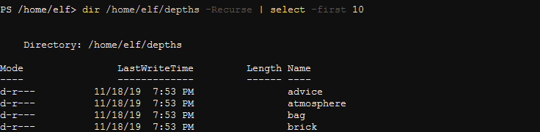  
   That works. Now, sort by the length of FullName or Fullname.Length  
   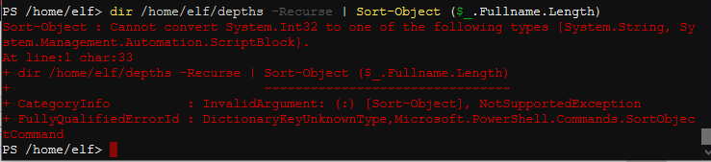  
   Oops, trouble. It turns out that when you do a computation ($_.FullName.Length), Sort-Object wants it to be in a script block (curly braces), not parenthesis.  
   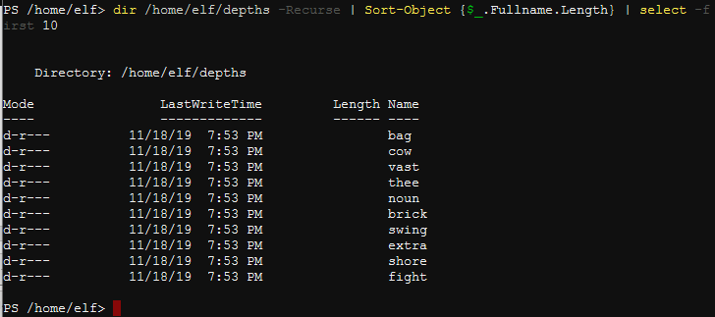  
   Good, except the short pathnames are at the top. Switch to -Descending.   
   dir /home/elf/depths -Recurse | Sort-Object {$_.Fullname.Length} -Descending | Select-Object -First 1  
   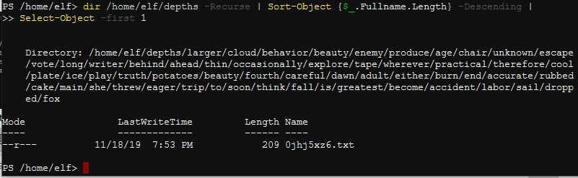  
     
   That’s a long path! Rather than copy the whole mess and paste it into a Get-Content cmdlet, we can pipe it.  
   dir /home/elf/depths -Recurse | Sort-Object {$_.Fullname.Length} -Descending | Select-Object -First 1 | Get-Content  
   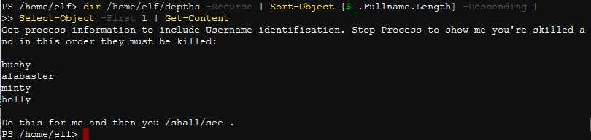

You’ll be using Get-Process and Stop-Process for this one. They mention Username for a reason.

## Question

1. What is the next riddle? Note the part of this riddle, “then you /shall/see .”